SIMATS ENGINEERING

CO3- AT2 - Design Task - Medium
COURSE NAME: Advance Wireless Communication Systems
/ 5G / 6G Communication Systems COURSE CODE: ECA56

COURSE OUTCOME COVERED

CO: 3 - Design spectrum access strategies, waveform generation methods, and multiple access techniques for efficient wireless transmission systems. (BL6)

Assessment Tool Number : CO3_AT2 Assessment Tool Weightage : 35% Assessment Tool : Design Task Duration : 180 Minutes
Marks : 100 Marks
Type of Assessment Conduction : At Home Evaluation Type : GitHub
Result Generation : Students design and justify appropriate wireless communication
solutions by applying engineering principles to meet specified requirements.
Topic Covered :
Spectrum management, licensed/unlicensed spectrum, dynamic spectrum access, cognitive radio, OFDMA, resource block allocation, GFDMA, NOMA, power- domain multiplexing, SIC, and IoT applications. Advanced waveforms and wireless technologies including GFDM, FBMC, UFMC, mmWave propagation, path loss and penetration, millimeter-wave antenna systems, MIMO, and Massive MIMO fundamentals.

Short description about assessment: Students design a system / model based on given requirements to assess creativity and application skills. This question paper consists of a total of 40 questions, out of which each student is required to answer any 2 questions. Each question carries 50 marks, and the paper carries a total of 100 marks

QUESTIONS: 2 (2 X 50 = 100) Total Marks: 100 Duration: 3hrs
29. Design a 5G-enabled IoT framework for campus automation.
34. Develop an energy monitoring communication model for public infrastructure.

Code of Conduct:

I H. Yaswanth (192412440) (Name / Reg No) certify that this submission is my original work and that I have adhered to the guidelines specified for this assessment. I understand that any violation of academic integrity rules will result in disciplinary action.

Signature of the student:

RUBRICS FOR CALCULATION:
Design Task
Criteria | Weightag e | Level 4 (Exemplary) | Level 3 (Proficient) | Level 2 (Developing) | Level 1 (Beginning)
Understandin g of Design | 20% | Demonstrat es deep understandin g of design objectives, constraints, and context | Shows good understandin g with minor gaps | Partial understandin g; misses key  aspects | Lacks understan din g of the design context
Evaluation of Design | 25% | Provides in depth critique identifying strengths, weaknesse s, and design gaps | Identifies key issues with reasonable analysis | Limited critique; mostly descriptive feedback | No meaningful critique provided
Justification | 20% | Supports critique with strong reasoning, evidence, and relevant principles | Provides justification with some supporting evidence | Weak or unclear justification | No justification for feedback
Suggestions for Improvement | 20% | Offers innovative, practical, and well-justified improvement suggestions | Provides useful suggestions with minor gaps | Suggestions are limited or partially relevant | No constructiv e suggestio ns provided

Communicat io n | 15% | Communicate s feedback clearly, professionall y, and engages actively in discussion | Communicate s well with minor issues | Communicatio n lacks clarity or engagement | Poor communica tio n and minimal participation

29. Design a 5G-enabled IoT framework for campus automation

Aim:

To design and simulate a 5G-enabled IoT framework for campus automation and analyze the communication latency of IoT devices connected through a 5G network.

Program Code:

clc;

clear;

close all;

devices = 1:50;

sensorLatency = 5 + 2*rand(1,50);

fiveGLatency = 2 + rand(1,50);

totalLatency = sensorLatency + fiveGLatency;

figure;

plot(devices,totalLatency,'b-o','LineWidth',1.5);

xlabel('Number of IoT Devices');

ylabel('Communication Latency (ms)');

title('5G-Enabled IoT Framework for Campus Automation');

grid on;

avgLatency = mean(totalLatency);

disp(['Average Communication Latency = ', ...

num2str(avgLatency), ' ms']);

Output:

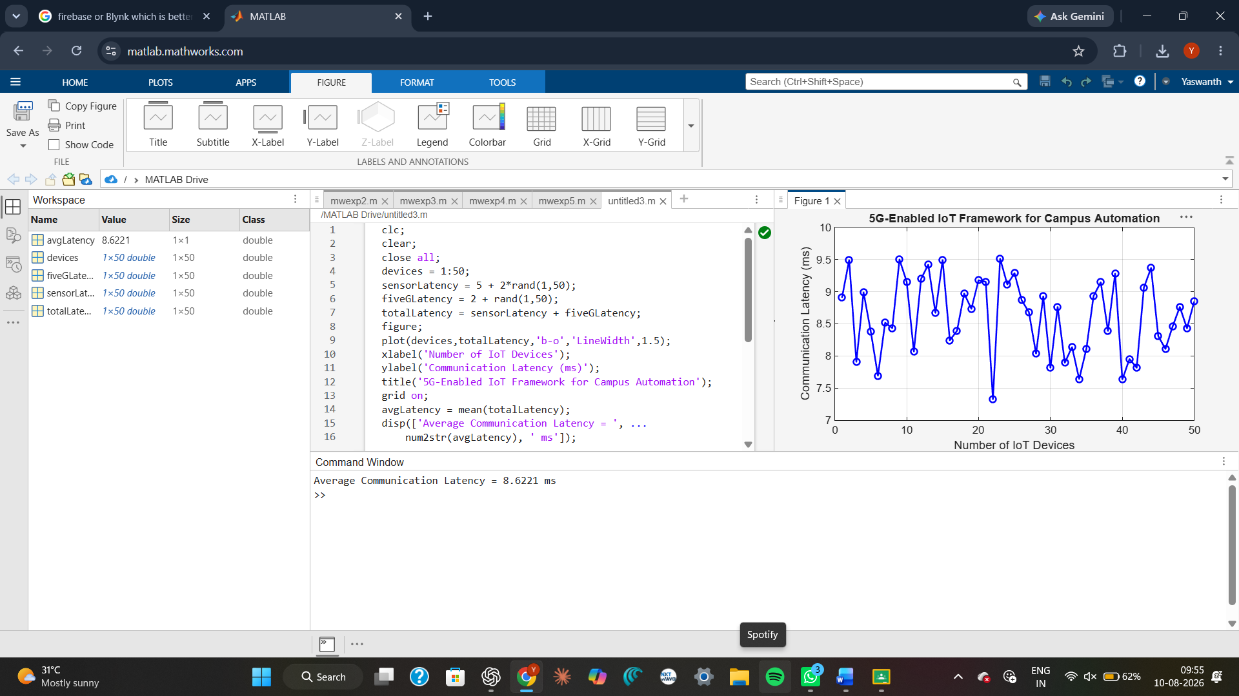

Result:

The 5G-enabled IoT framework for campus automation was successfully simulated in MATLAB. The graph shows the communication latency experienced by different IoT devices connected through the 5G network. The average communication latency was calculated, demonstrating the capability of 5G communication to support low-latency campus automation applications.

34. Develop an energy monitoring communication model for public infrastructure

Aim:

To develop and simulate an energy monitoring communication model for public infrastructure and analyze the variation in energy consumption over a 24-hour period.

Program Code:

clc;

clear;

close all;

time = 0:23;

baseEnergy = 20 + 5*rand(1,24);

peakHours = (time >= 9 & time <= 17);

energyConsumption = baseEnergy + ...8*peakHours;

figure;

plot(time,energyConsumption,'r-o','LineWidth',1.5);

xlabel('Time (Hours)');

ylabel('Energy Consumption (kWh)');

title('Energy Monitoring Communication Model');

grid on;

avgEnergy = mean(energyConsumption);

totalEnergy = sum(energyConsumption);

disp(['Average Energy Consumption = ', ...num2str(avgEnergy), ' kWh']);

disp(['Total Daily Energy Consumption = ', ...num2str(totalEnergy), ' kWh']);

Output:

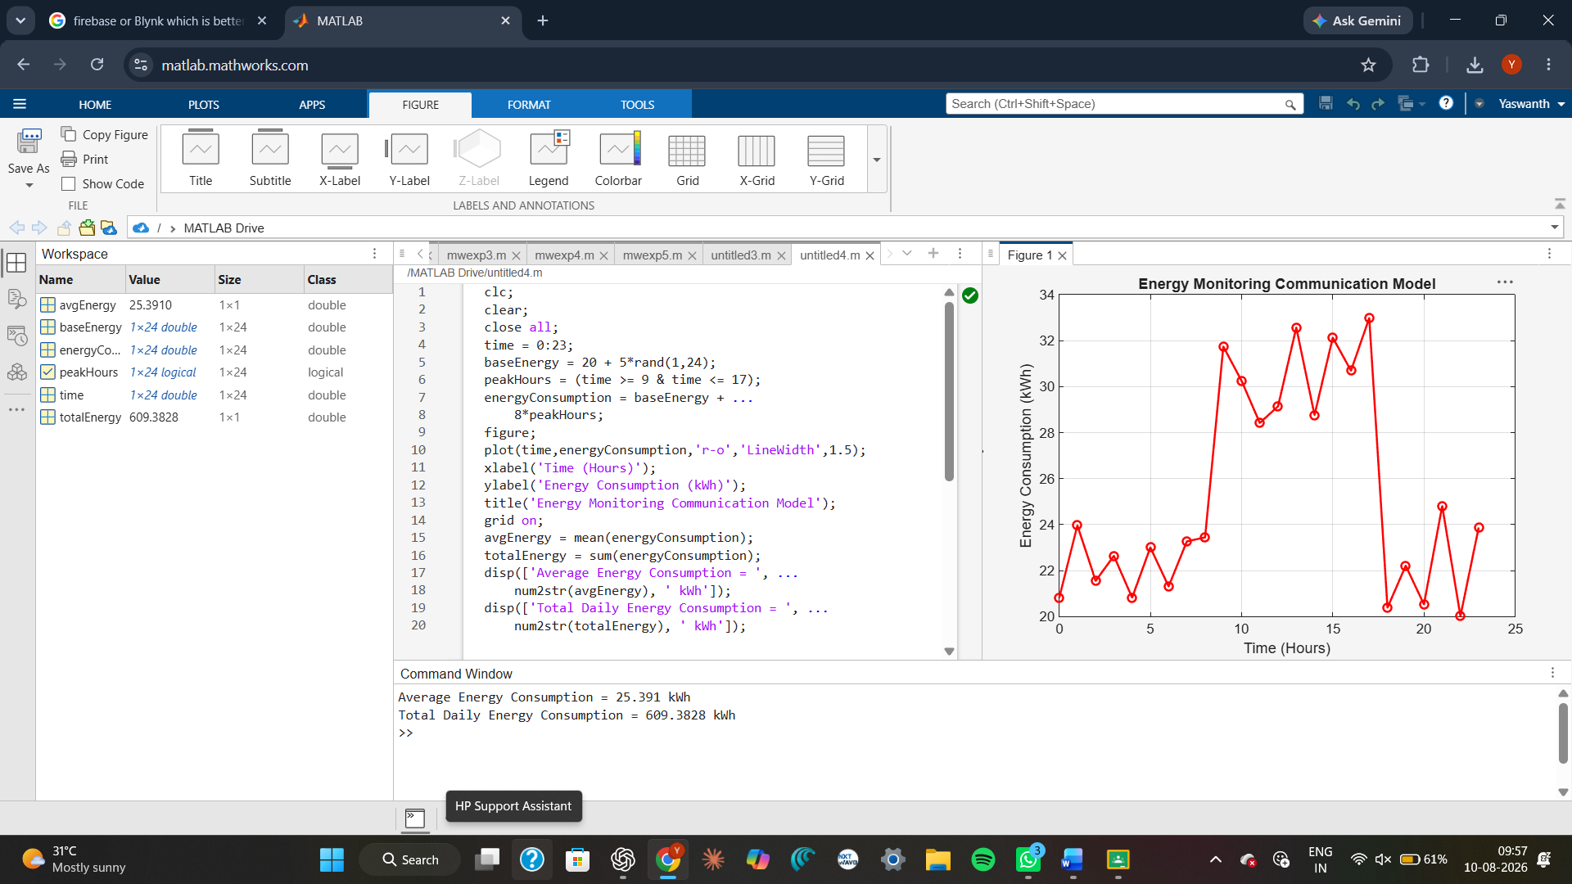

Result:

The energy monitoring communication model for public infrastructure was successfully simulated in MATLAB. The graph shows the variation in energy consumption over a 24-hour period, with higher consumption during peak hours. The average and total daily energy consumption were calculated, demonstrating the usefulness of wireless energy monitoring for efficient infrastructure management.

